# **Practice Assignment 304.4.1**

# **Simple Queries**

# 

**Prerequisites**

For this lab, you must have the “**classicmodels”** database. If you do not have the **classicmodels** database setup, [**click here to download the database script file**.](https://drive.google.com/file/d/1JoT6N-kNhJ048ahXvvSgWNE0737NAdbb/view?usp=sharing) After downloading, you have to run the **classicmodels.sql**file in SQL.

**The database schema is as follows:**

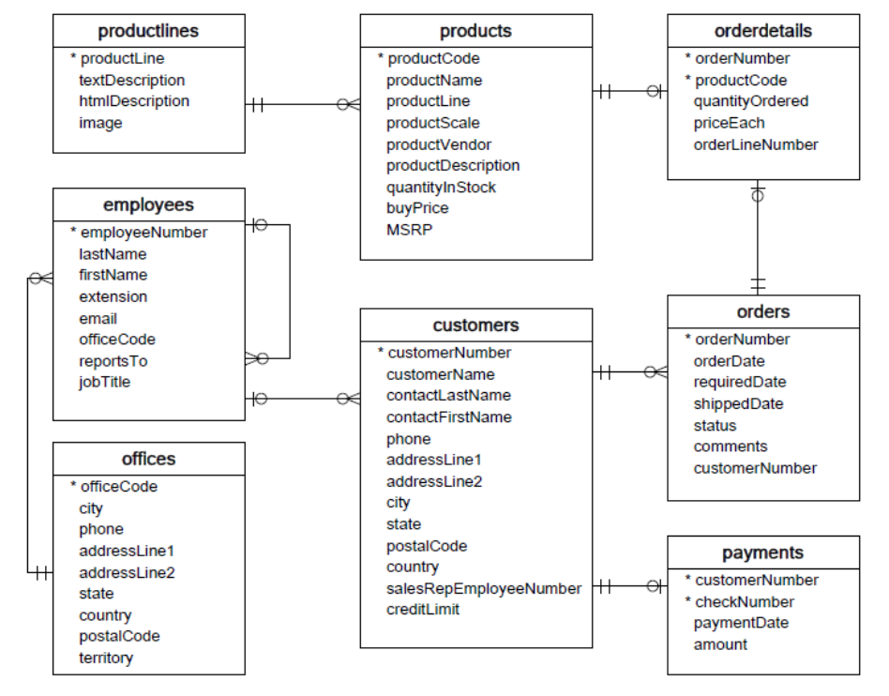

## **Objective**

## You will be writing SQL queries for this assignment. This assignment tests your understanding of SQL queries and SQL clauses.

**Instructions**

Write SQL queries to accomplish the following tasks:

## Display the **name**, **product line**, and **buy price** of all products. The output columns should display as: “Name,” “Product Line,” and “Buy Price.” The output should display the most expensive items first.

## Display the **first name**, **last name**, and **city name** of all customers from Germany. The output columns should display as: “First Name,” “Last Name,” and “City.” The output should be sorted by “Last Name” (ascending).

## Display **each of the unique values of the status field** in the orders table. The output should be sorted alphabetically, ascending.

## Hint: The output should show exactly six rows.

## Display **all fields** from the payments table for payments made on or after January 1, 2005. The output should be sorted by the payment date from highest to lowest.

## Display the **last Name, first Name, email address, and job title** of all employees working out of the San Francisco office. The output should be sorted by “Last Name.”

## Display the **name, product line, scale, and vendor** of all of the car products – both classic and vintage. The output should display all vintage cars first (sorted alphabetically by name), and all classic cars last (also sorted alphabetically by name).

**Submission**

Please include the following deliverables in your Canvas submission:

* All queries, which should be written and submitted in a single SQL script file.
  + Example: **<your_name_labname>.sql**.
  + **Do not add the questions in your SQL script file.**

Submit your SQL script file using the **Start** **Assignment** button on the assignment page in Canvas.